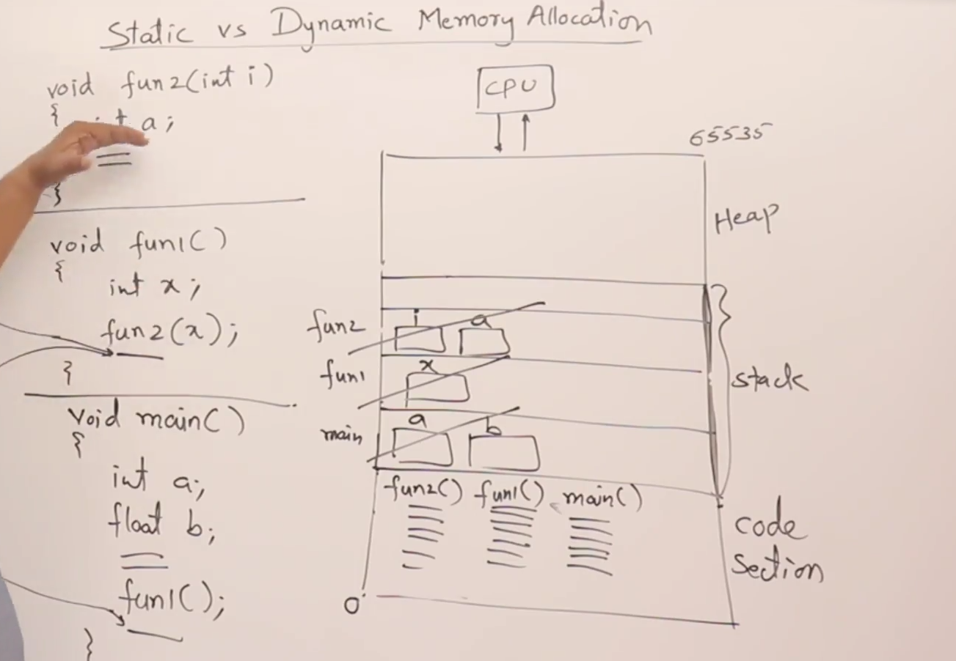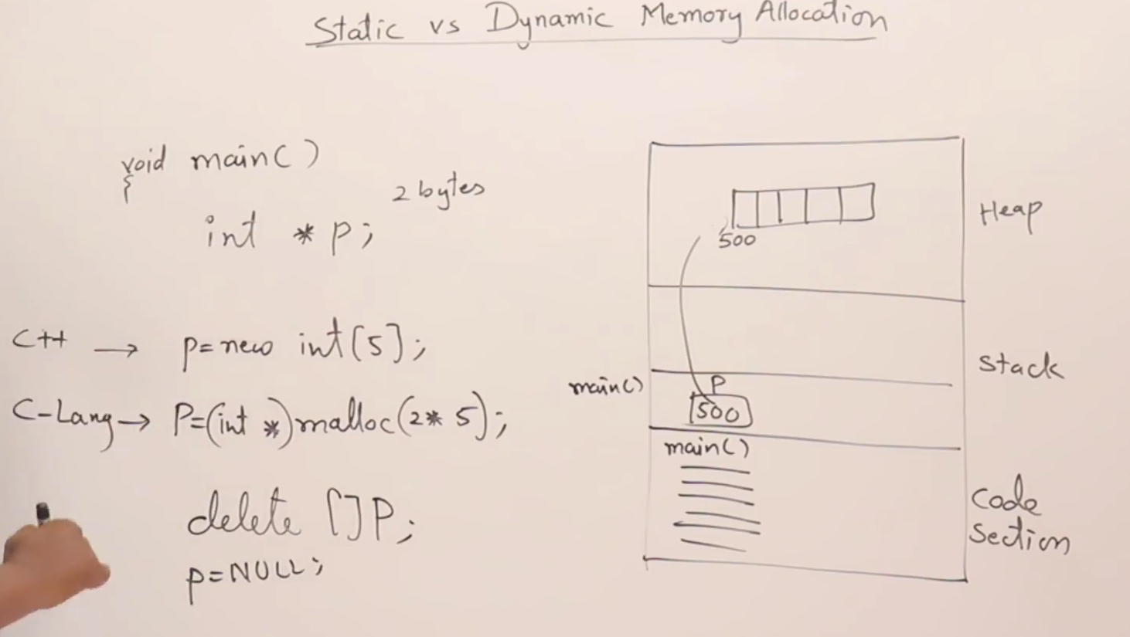

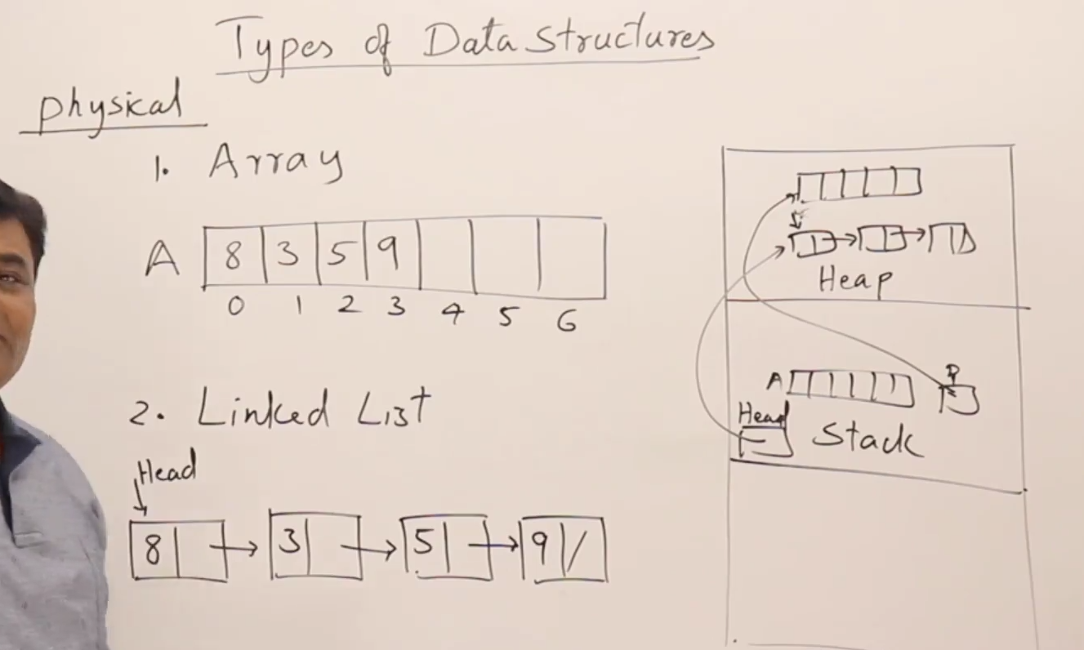



***Understanding Physical vs Logical Data Structures***

In computer science, the distinction between physical and logical data structures is fundamental to how data is organized, accessed, and manipulated. Each type serves a different purpose and operates at different levels of abstraction.

**Physical Data Structures**

**Definition**: Physical data structures refer to the actual arrangement of data in a computer's memory. This includes how data is stored, accessed, and manipulated at the hardware level.

* **Characteristics**:
  + Concerned with the **low-level representation** of data.
  + Implementation details are crucial for performance and efficiency.
  + Examples include arrays, linked lists, stacks, queues, trees, and graphs.
* **Performance Impact**: The choice of physical data structure can significantly affect the speed of data access and manipulation. For instance:
  + An array allows for quick access to elements via indexing but can be costly to resize.
  + A linked list can provide efficient insertions and deletions but may require more memory due to pointers

**Logical Data Structures**

**Definition**: Logical data structures represent the abstract organization of data independent of how it is physically implemented. They focus on how users interact with data and how it relates to other data.

* **Characteristics**:
  + Abstract concepts that define the relationships and operations on data.
  + Often represented in a way that is intuitive for users, such as tables in databases or nodes in trees.
* **Examples**: Common logical data structures include:
  + **Stacks**: Follow Last-In-First-Out (LIFO) principle.
  + **Queues**: Follow First-In-First-Out (FIFO) principle.
  + **Trees**: Hierarchical structures where nodes represent relationships.
  + **Graphs**: Collections of vertices connected by edges

**Key Differences**

| **Aspect** | **Physical Data Structures** | **Logical Data Structures** |
| --- | --- | --- |
| **Definition** | Actual organization of data in memory | Abstract representation of data |
| **Focus** | How data is stored and accessed | How users perceive and interact with data |
| **Examples** | Arrays, linked lists, trees | Stacks, queues, graphs |
| **Performance Impact** | Affects speed and efficiency of algorithms | Influences design but not directly performance |
| **Abstraction Level** | Low-level (hardware) | High-level (conceptual) |

**Conclusion**

Understanding the difference between physical and logical data structures is essential for effective algorithm design and implementation. While physical structures deal with the specifics of memory management and performance optimization, logical structures provide a framework for organizing and manipulating data conceptually. This separation allows developers to write more efficient code while maintaining clarity in how data is represented and used within applications

